2.18: a) The velocity at t = 0 is

(3.00 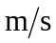) + (0.100 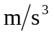) (0) = 3.00 ,

and the velocity at t = 5.00 s is

(3.00 ) + (0.100 ) (5.00 s)² = 5.50 ,

so Eq. (2.4) gives the average acceleration as
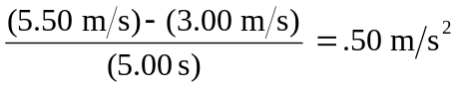.

b) The instantaneous acceleration is obtained by using Eq. (2.5),

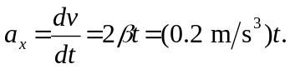

Then, i) at t = 0, a_{x} = (0.2 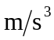) (0) = 0, and
ii) at t = 5.00 s, a_{x} = (0.2 ) (5.00 s) = 1.0 

